NY bookings | NY Museum - https://www.amnh.org/ $23pp  Stat of lib pedestal – book www.statuecruises.com

Day 1

Hotel name | Millennium Hilton New York One UN Plaza
No of nights | 3
Travel to | Airport taxi 30 mins - Fixed yellow cab fare $52 plus tolls and tip
Location | Nr UN HQ
Address | One UN Plaza, New York 10017
Hotel website | https://www.hilton.com/en/hotels/nycuphh-millennium-hilton-new-york-one-un-plaza/

Day 2 - American museum of natural history
Name | American Museum of Natural History
Website | https://www.amnh.org/
Add | 22 Central Park West
Cost | $23pp
Timings | Wednesday-Sunday, 10 am–5:30 pm
Distance from Hotel | 24 mins (2 subways)

Getting around:
Buy 1 metro card per 4 people for $1 and pre load (2.75 per journey with changes allowed)
OR tap and go (up to 4 people) - swipe the card multiple times for 4 people
(if buy metro card -use 99999 as If you do not have an American zip code)

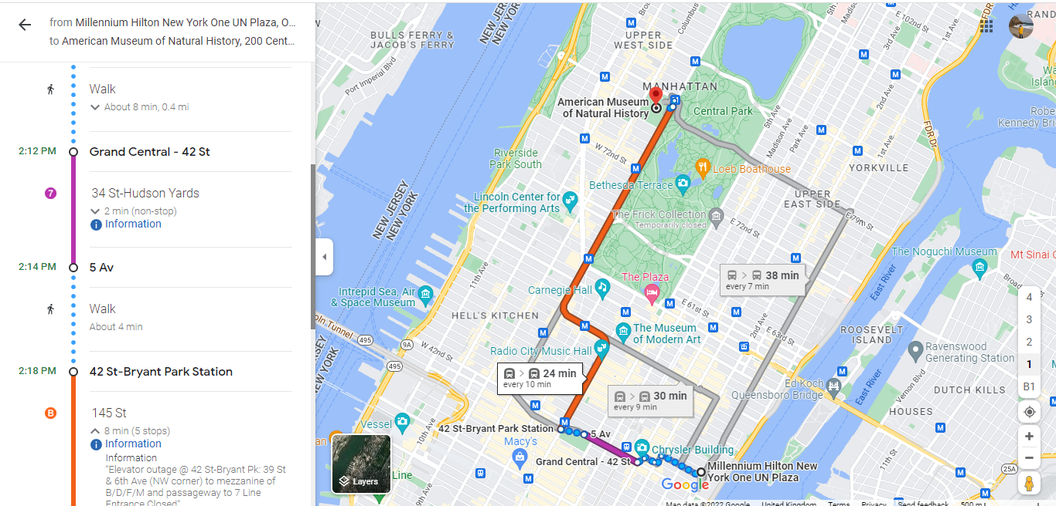

Eating
Best diner – Ellens Time Sq - 28 mins walk from hotel
https://www.ellensstardustdiner.com/
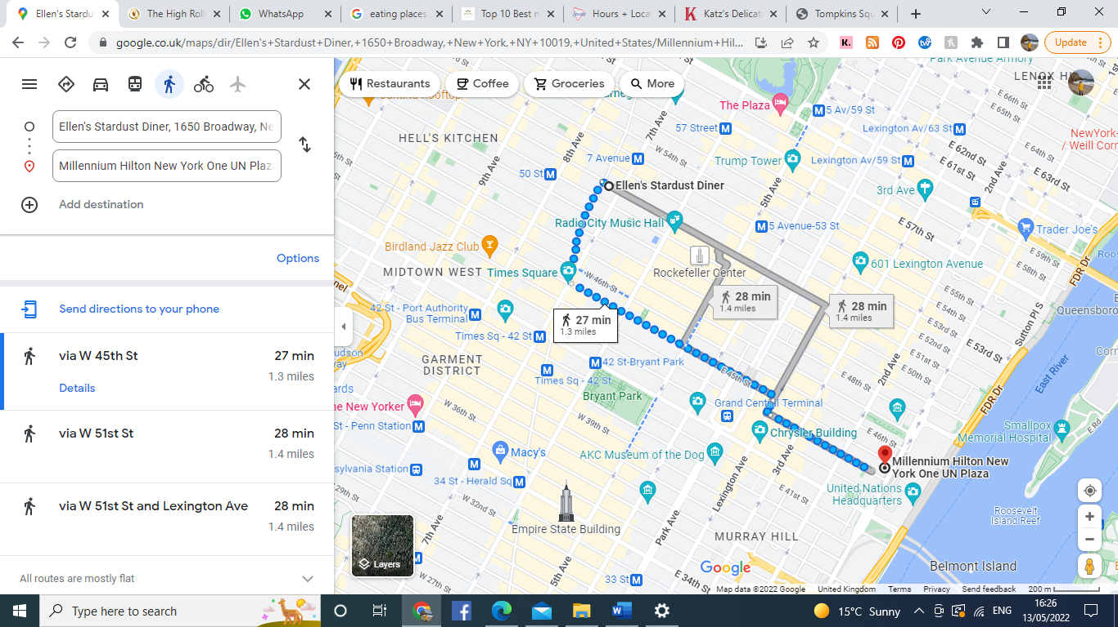
Best bagel
1. Russ and daughters - 179 E Houston St | NYC 10002 – 40 min walks
2. Brooklyn bagel and coffee co
Chelsea 286 8th Ave. 43 mins walk from hotel
Greenwich village - 63 E 8th St. – 45 min walk south from hotel
3. Thompkins Square bagels - Tompkins Square Bagels, 165 Avenue A, New York, NY 10009, United States (38 mins south)

Day 2 – Statue of Liberty/ Ellis island
Name | Statue of liberty
Website | www.statuecruises.com https://www.cityexperiences.com/new-york/city-cruises/statue/cruises/new-york-pedestal-reserve/
Add | Statue city cruises Battery park
Cost | $24.30
Timings | 1pm
Directions | 25 mins subway

